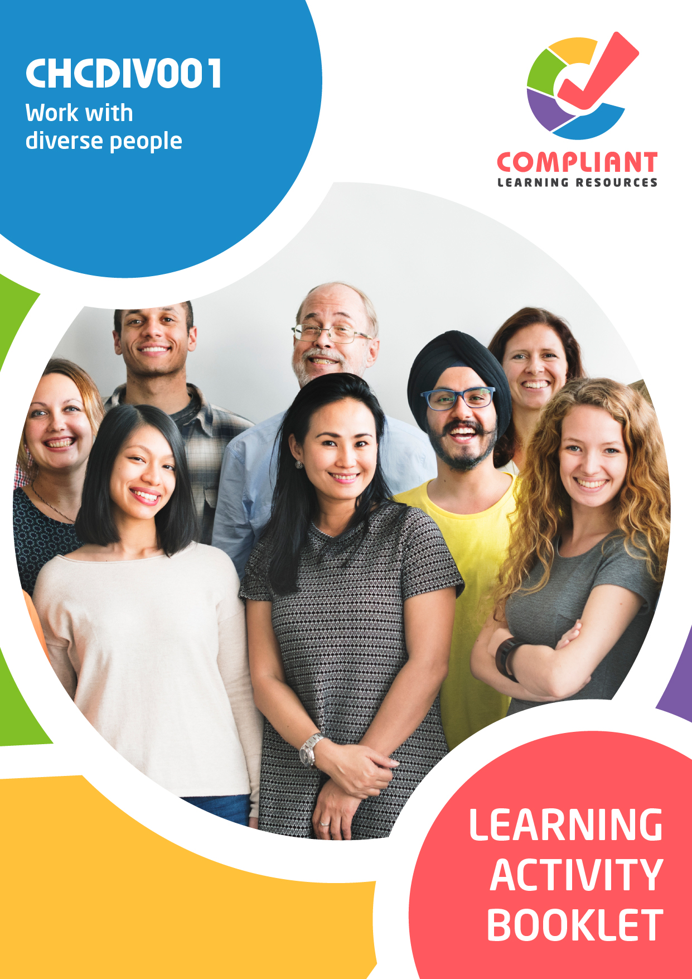

**Copyright**

This document was developed by Compliant Learning Resources.

© 2023 Compliant Learning Resources.

All rights reserved.

No part of this publication may be reproduced, stored in a retrieval system, or transmitted in any form or by any means, electronic, mechanical, photocopying, recording, or otherwise without the prior written permission of Compliant Learning Resources.

**Version Control & Document History**

|  |  |  |
| --- | --- | --- |
| **Date** | **Summary of Modifications** | **Version** |
| 21 May 2021 | Version 1.0 released for publishing | 1.0 |
| 10 August 2022 | Version 2.0 released for publishing   * Updated based on changes made to the Learner Guide | 2.0 |
| 19 May 2023 | Version 2.1 released for publishing   * Fixed minor wording issues | 2.1 |
| 25 May 2023 | Version 2.2 endorsed for use   * Revised Activity 3.2 | 2.2 |

# Table of Contents

Overview 4

Learner Instructions 5

Learner Information 5

Trainer Information 5

Resources Required 6

Work Health and Safety 6

Reasonable Adjustment 7

Formative Activities 8

I. Reflect on Own Perspectives 8

Activity 1.1 8

Activity 1.2 8

II. Appreciate Diversity and Inclusiveness, and Their Benefits 9

Activity 2.1 9

Activity 2.2 10

III. Communicate with People from Diverse Backgrounds and Situations 11

Activity 3.1 11

Activity 3.2 12

IV. Promote Understanding Across Diverse Groups 13

Activity 4.1 13

Activity 4.2 14

Activity 4.3 15

# Overview

**CHCDIV001 - Work with diverse people (Release 1)**

This unit describes the skills and knowledge required to work respectfully with people from diverse social and cultural groups and situations, including Aboriginal and/or Torres Strait Islander people.

This unit applies to all workers.

*The skills in this unit must be applied in accordance with Commonwealth and State/Territory legislation, Australian/New Zealand standards and industry codes of practice.*

**A complete copy of the above unit of competency can be downloaded from the TGA website:**

<https://training.gov.au/Training/Details/CHCDIV001>

# Learner Instructions

This Learning Activity Booklet contains formative activities that learners will complete in the classroom or a similar environment.

These formative activities include knowledge questions to test your underpinning generic knowledge and practical activities to test your skills relevant to the unit/s of competency.

These formative assessments are used by your trainer to complement both the learning and training processes, and to evaluate how you are progressing throughout these processes.

You may reference your Learner Guide and other learning materials to complete the activities included in this workbook.

**IMPORTANT:**

**The completion of the formative assessments and learning activities included in this workbook DOES NOT lead to a Qualification or a Statement of Attainment (SOA).**

## Learner Information

|  |  |
| --- | --- |
| Learner name |  |
| Phone |  |
| Email |  |

## Trainer Information

|  |  |
| --- | --- |
| Trainer name |  |
| RTO name |  |
| RTO phone |  |
| RTO email |  |

# Resources Required

Resources needed to complete activities included in this workbook include:

* Computer with Internet, email access, and a working web browser
* Installed software: MS Word, Adobe Acrobat Reader
* Learner guide

# Work Health and Safety

Both the trainers and learners have duty of care in ensuring that the learning environment is free from hazards that may pose risks to their health and safety.

According to WHS legislation, trainers and learners must take reasonable care while undertaking the activities included in this workbook in the learning environment.

# Reasonable Adjustment

‘Reasonable adjustment’ in VET is the term applied to modifying the learning environment or making changes to the training delivered to assist a learner with a disability. A reasonable adjustment can be as simple as changing classrooms to be closer to amenities or installing a particular type of software on a computer for a person with vision impairment.

**Why make a reasonable adjustment?**

We make reasonable adjustments in VET to make sure that learners with disabilities have:

* The same learning opportunities as learners without disabilities, and
* The same opportunity to perform and complete assessments as those without disabilities.

**Reasonable adjustment applied to participation in teaching, learning, and assessment activities can include:**

* Customising resources and assessment activities within the training package or accredited course
* Modifying the presentation medium
* Learner support
* Use of assistive/adaptive technologies
* Making information accessible both before enrolment and during the course
* Monitoring the adjustments to ensure learner needs continue to be met

**Assistive/Adaptive Technologies**

Assistive/adaptive technology means ‘software or hardware that has been specifically designed to assist people with disabilities in carrying out daily activities’ (World Wide Web Consortium - W3C). It includes screen readers, magnifiers, voice recognition software, alternative keyboards, devices for grasping, visual alert systems, and digital note-takers.

*(Adapted Reasonable Adjustment in teaching, learning and assessment for learners with a disability - November 2010 - Prepared by - Queensland VET Development Centre)*

**IMPORTANT:**

**Reasonable adjustment made for collecting learner assessment evidence must not impact the standard expected by the workplace, as expressed by the relevant unit/s of competency. For example, if the assessment were gathering evidence of the learner’s competency in writing, allowing the learner to complete the assessment verbally would not be a valid assessment method. The method of assessment used by any reasonable adjustment must still meet the competency requirements.**

# Formative Activities

## I. Reflect on Own Perspectives

### Activity 1.1

|  |  |
| --- | --- |
| **True or False**  Review the statements below about biases, perspectives, inclusivity, awareness and human rights. Indicate whether each statement is true or false.  Tick the box that corresponds to your answer. | |
|  | |
| TRUE  FALSE | 1. Cultural bias is your predisposition to favour one set of values, behaviour, and knowledge over another. |
| TRUE  FALSE | 1. Cultural perspective is your view of or the particular attitude you have towards a community, society or a group of people. |
| TRUE  FALSE | 1. Social bias entails understanding how a person’s social traits may inform their values, behaviour, beliefs and basic assumptions. |
| TRUE  FALSE | 1. Human rights are based on the obligation to yourself and others as human beings to uphold liberty, dignity, equality, fairness, respect, and independence. |
| TRUE  FALSE | 1. To work inclusively means to work in a way that upholds and protects the rights and dignity of all persons. |

### Activity 1.2

|  |
| --- |
| Identify three principles to follow when improving yourself. |
|  |
|  |
|  |
|  |

## II. Appreciate Diversity and Inclusiveness, and Their Benefits

### Activity 2.1

|  |
| --- |
| **Fill in the blanks**  The following are statements on inclusiveness and diversity in the workplace and the practices that promote these values. Review each and complete the statement by filling in the missing words/phrases. |
|  |
| 1. refers to differences between aspects or characteristics of cultures.       is allowing equal opportunities and participation to people despite differences in culture. |
| 1. are the principles, beliefs, and practices that are considered intrinsically desirable by a cultural group.       are typically seen as behaviour patterns that a cultural group demonstrates. |
| 1. Western       refer to the west’s set of principles and procedures for performing actions and carrying about daily life. Western       refer to the west’s set of social institutions and patterns of relationships, such as in communities, families and governments. |
| 1. factors are entities or situations that can cause negative effects. The opposite happens with       factors, where positive effects come up. |
| 1. is the unjust and prejudicial treatment of a group of people.       means being removed from the bigger group. |

### Activity 2.2

|  |  |
| --- | --- |
| List two advantages and two disadvantages of developing professional relationships that are based on acceptance of cultural diversity. | |
|  | |
| **Advantages** | **Disadvantages** |
|  |  |
|  |  |

## III. Communicate with People from Diverse Backgrounds and Situations

### Activity 3.1

|  |  |
| --- | --- |
| **Matching Type**  Listed below are concepts related to the use of communication.   1. Language barrier 2. Written language 3. Language interpretation 4. Diversity in communication 5. Constructive communication   Match each to their description below by writing the letter that corresponds to your answer in the space provided. | |
|  | |
| Description | | |
|  | 1. It is a style of communication used when addressing issues or resolving conflicts. | |
|  | 1. It refers to the different ways of communicating with the persons in your workplace. | |
|  | 1. It occurs when two people cannot communicate due to differences in their language. | |
|  | 1. It is the process through which one expression or source of information provided through a certain language is expressed in a different language. | |
|  | 1. It is part of non-verbal communication. It can refer to both the characters of the alphabet and the symbols and pictures people draw to convey meaning. | |

### Activity 3.2

|  |
| --- |
| **SCENARIO**  Jane is a young woman who came to the community centre to ask for assistance in interviewing an Aboriginal child as part of her work. As an Australian woman who speaks English, she felt that it was necessary to get proper help before approaching a family. Jane was scheduled to meet John, a fourteen-year-old Aboriginal boy whose father is a *mayutju* or esteemed member of his Aboriginal community. John was described as a shy boy who preferred keeping to himself rather than playing with children of his age. He spent much of his time listening to music wherever he heard it and only spoke when talked to.  On the day of the interview, Jane went to the interview alone. Jane found it difficult to communicate with John. When asked questions, he would either provide no response or would answer inappropriately with a “yes” or a “no.” When he did give detailed responses, he had difficulties expressing his ideas in English and used words that were unfamiliar to Jane.  Realising the communication challenges with John, she changed her approach. First, she tried to engage John in conversations about his interests. She also gave him enough time to reflect on his answers when she asked him questions. She avoided interrupting John whenever he shared his thoughts. John began to express himself more freely. |
| Before her second meeting with John, Jane went to the community centre and asked for assistance. After hearing of Jane’s experiences, an interpreter was assigned to guide and assist Jane with her task by giving her a set of instructions on what to do. She also prepared visual aids to accompany her questions.  During the second interview, John understood the questions better. He was more comfortable and participative. |

|  |
| --- |
| List two effective communication approaches Jane used. |
|  |
|  |
|  |

## IV. Promote Understanding Across Diverse Groups

### Activity 4.1

|  |  |
| --- | --- |
| **True or False**  Review the statements below about resolving cross-cultural conflicts. Indicate whether each statement is true or false.  Tick the box that corresponds to your answer. | |
|  | |
| TRUE  FALSE | 1. Making a hasty generalisation of a society or community may cause misunderstandings in the workplace. |
| TRUE  FALSE | 1. Bias and discrimination can be tolerated on any level within a workplace. |
| TRUE  FALSE | 1. When resolving conflicts involving differences in culture, how you resolve the issue is just as important as what your resolution is. |
| TRUE  FALSE | 1. One sensitive resolution to a conflict is identifying a person’s cultural traits and characteristics as the source of the problem. |
| TRUE  FALSE | 1. You must seek assistance when dealing with a person from a cultural or social background you are not familiar with. |

### Activity 4.2

|  |  |  |  |  |  |  |
| --- | --- | --- | --- | --- | --- | --- |
| **Matching Type**  Identify the form of discrimination being described in each statement below.   |  | | --- | | **Form of Discrimination** | | Racism | | Prejudice | | Ageism | | Stereotypes | | |
|  | |
| Definitions | |
|  | 1. A situation where people nearing or past the retiring age are treated very differently in the workplace compared to the ideal working ages. |
|  | 1. Majority-held beliefs about social groups that can either be positive or negative. |
|  | 1. Usually refers to a negative pre-judgment. |
|  | 1. A situation where a person is treated less favourably than another, due to their race, ethnicity, national origins, nationality, or colour. |

### Activity 4.3

|  |
| --- |
| Explain the impact of cultural diversity on misunderstandings and provide two actions when mediating between two arguing parties. |
|  |
| Explain the impact of cultural diversity on misunderstandings. |
| Provide two ways to make an effort to resolve differences sensitively. |

End of Document